PATIENT PARTICIPATION GROUPS

COMMUNITY HEALTH
OPEN DAY
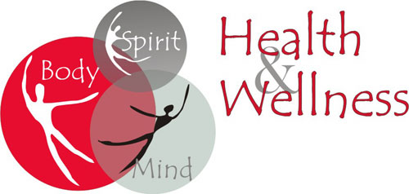
EVERYONE WELCOME
NO APPOINTMENT NECESSARY!
THURSDAY 5TH OCTOBER 2017
2pm to 6.00pm
Dietician Diabetes Pharmacist Age Concern Healthwatch Mental Health Sports for Fun Podiatrist Care Services Citizens Advice Nurse- Practitioner TB awareness and others

SOUTH WOODFORD HEALTH CENTRE
114 HIGH ROAD, E18 2QS (ENTRANCE FROM HIGH ROAD)
Chandra Patel (Elmhurst) 07961 145592, Rakesh Dutta (Queen Mary) 07931 514129, Michelle Greene (Shrubberies) 020 8505 8354

